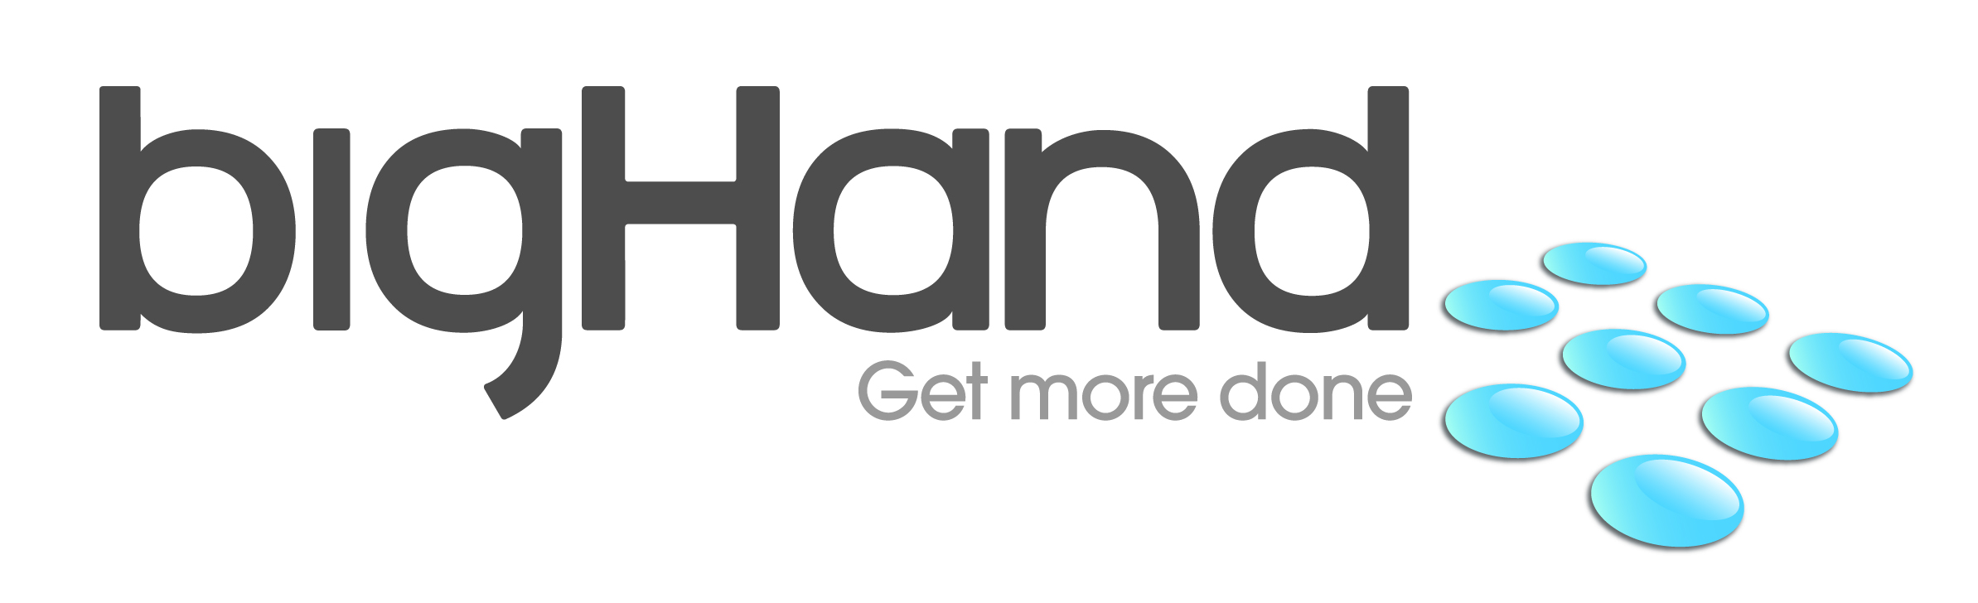

DISCLOSURE STATEMENT PREPARED BY
----------------------------------------------------------------------------------------------------------------------------------------------

BigHand Software Pty Ltd

----------------------------------------------------------------------------------------------------------------------------------------------
AS AT 12/02/2015

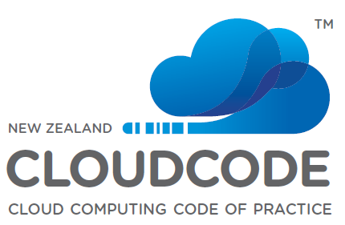

1 Introduction

For an organisation to be a CloudCode Signatory they must wholly disclose the following information to all clients, both prospective and current, before, during and after the sales process. They must update their Disclosure Document and inform the Register of CloudCode Signatories of these changed disclosures as soon as possible and not later than 28 days after the change is made. Where the change has a material effect on the Cloud product or service being provided, they must notify all clients of these changes.

The CloudCode website provides more information of what constitutes a material change. The standard areas of disclosure required by the CloudCode are:

Corporate Identity

Company name: ...................................... Bighand Software Pty Ltd

Company Registration Number: ........ ...... ABN 74131578544

Trading name: ........................................... BigHand Software Pty Ltd

Physical address: ...................................... Level 11, 92 Pitt St, Sydney, NSW 2000

Postal address: .......................................... Level 11, 92 Pitt St, Sydney, NSW 2000

Company website:..................................... www.bighand.com
Contact phone number: ............................ +61 2 9231 8900

Contact email address: ............................. Anthony.bleasdale@bighand.com

Complaints about our service can be made in the first instance to. Anthony Bleasdale, Director, BigHand APAC, +61 2 9231 8900.
Contact person responsible for these disclosure statements can be contacted via the following email address: Anthony Bleasdale, Director, BigHand APAC, +61 2 9231 8900

The disclosures herein apply to the following products or services supplied by us:

• BigHand Professional as described at www. www.bighand.com/apac/our-customers/bighand-professional

• Product type/name. as described at www. Enter URL.

• Product type/name. as described at www. Enter URL.

• Product type/name. as described at www. Enter URL.

For the purpose of Legal Jurisdiction, the contracted supplier who provides the service to you is a Proprietary Limited Company registered in Australia

The governing law of our contract with you is NSW

The disclosure statements that follow have been Self assessed

2. Ownership of Information

We do not claim ownership of any data or information uploaded to our service.

Your data and information may traverse or be stored on our upstream provider’s networks or systems. In these instances that provider considers the data and information that you use or transmit via our service as owned by the client

Metadata and other statistical information, such as anonymised data generated as a result of the use of our service, is owned by the client and is not used for any other purposes.

Security

As at the date of application:

    - We are not listed on the CSA STAR Registry but currently applying

(delete one of the following statements)

    - We formally meet the following security related standards: IS)/IEC 27001:2005 at level globally which have been Assessed externally by BSI

    - We have the following physical security in place at the data centres hosting your data:
▪ Individual credential checks prior to authorisation. ▪ 24/7 onsite security personnel. ▪ Biometric fingerprint security for data centre access.▪ Anti-cloning access card encryption. ▪ Secure lifts between floors. ▪ Intruder-resistant glass, steel mesh and solid concrete walls. ▪ Secure loading dock for deliveries. ▪ Extensive coverage of motion sensitive CCTV cameras. ▪ Remote monitoring and control of rack access via ONEDC®. ▪ Monitoring of news and weather for external security risks.

    - We have the following digital security in place on the systems hosting your data:
▪ Uptime Institute Tier III certification of design documents. ▪ Uptime Institute Tier III certification of constructed facility. ▪ Certified to ISO 9001:2008 for the design, development and provision of secured data Centre infrastructure and associated services. ▪ Designed by ASIO T4 accredited consultants with ASIO T4security and future requirements of the Protective Security Policy framework (PSPF) in mind. ▪ Designed in accordance with the Telecommunications Industry Association’s (TIA) 942 standard (Tier III).

Data Location

    - SYDNEY
    - Our Backup/Disaster recovery systems that hold your data are located Melbourne, NEXT DC data centre

Additional information about data location:
- Click here to enter text.Built to the Australian Earthquake Loading Standard AS1170.Importance Level 4 (IL4).Power
- Individual credential checks prior to authorisation
- 24/7 onsite security personnel
- Biometric fingerprint security for data centre access
- Intruder-resistant glass, steel mesh and solid concrete walls
- Extensive coverage of motion sensitive CCTV cameras
- Direct free air cooling for data halls on the upper level.

Data Access and Use

Data access by you:

    - Your data may be accessed during the contract period as described in our contract with you.
    - Your data can be downloaded from our service during the service provision period via the
following formats voice files, bhf or wav files.

    - At the cessation of our service to you, your data will be available to access for seven days after the cessation.

(if answer above is “will be available” please complete the following statements, otherwise delete)
      - Access to this data will be granted via request for the bhf and wav files
      - There will not be additional charges for access to your data after the service has been ceased

Data access by us:

    - Deletion of all customer data at the cessation of our service to you takes place within seven days.

    - We use customer data for the following business functions:
n/a
Click here to enter text.
Click here to enter text.

    - We do not access customer data for any other purpose
    - We do not use customer data in order to generate revenue other than through provision of the service.

Data access by others:

    - If we are approached by law enforcement agencies it is our policy to.
seek legal advice to validate if we need to adhere to the enforcement request.

    - We do not provide access to customer data to third parties other than law enforcement agencies as set out above.

Backup and Maintenance

Understanding the backup procedures of your service provider and their maintenance policies allows the customer to make decisions on what further steps they may need to ensure their data is backed up sufficiently.

    - Backups are performed every Daily, Weekly and Nightly to different locations.

    - Backups include (tick those that apply)
system data
client data
statistical data
operating system data
other please state.

    - Backup data is stored onsite and offisite
    - Where backup data is stored offsite, the offsite location is 800. km from the location of the data being backed up
We test the restoration of backup data every Annually
and the test is conducted.. through a formal disaster recovery process.
    - Access to backup data or archive data is not available

    - Adhoc requests for restoration of customer data will be commenced within 7 days
    - We do allow client audits of backup data, costs of which will be carried by 28 days

    - Backup data is retained for 11 months

    - We do undertake a regular maintenance programme to ensure the reliability and stability of our cloud resources
    - We do undertake a regular maintenance programme to ensure the reliability and stability of our service offerings.

Geographic Diversity

    - Our service is provided via multiple locations
(if the service is provided via multiple locations, the following disclosures should be made, if the opposite is true both these statements can be deleted)

      - Our services are provided via both onshore and offshore locations

• Our services are provided from the following locations: Australia, America, Germany, Holland and United Kingdom.

• We operate offices in the following countries: Australia, North America, Germany, Holland, Hong Kong, Singapore and United Kingdom

SLA and Support

This section sets out the standard support mechanisms and service level agreements that apply to services.

• Our standard support hours are. 24 five days a week (local time unless stated otherwise).

• In the event of an unscheduled outage or incident, we will communicate the details of the issues and expected resolution times via email
    - When communicating an issue to us we prefer you to do so via email
    - Our standard response time to any support issue raised is priority 1 response within 30 mins, priority 2 response within 1 hour, priority 3 response within 4 Hours days, priority 3 response within 1 day and priority 5 with 1 day.
    - In the event of a major incident, we will update our notifications every 1 hour.

    - When communicating with you we will use .. email
( e.g. details provided by customer on application / email)

    - We do make incident reports available to our clients after a major incident.

    - We will shut down or isolate any service offering that is impacting, or will impact, service level agreements.

    - We do not require service offering specific tools to enable safe service offering shutdown or isolation if needed.

    - We operate an active/activebased service.
If ‘other” click here to state.

Additional information about SLA’s and support:

Data Transportability

(please delete the appropriate statement)

An API is not relevant to the service we offer.

    - Data will be available to download after we cease supplying service to you
(if data is available post service cessation, then the following statement will apply)

Data can be obtained via secure download site

    - There may be additional charges associated with accessing data after your service has ceased.

Business Continuity

Issue Priority | Response Time | Update Frequency | Resolution Target*
1 | 30 Minutes | Once every hour | < 8 Hours
2 | 1 Hour | Once every hour | < 48 Hours
3 | 4 Hours | Once per day | < 3 Days
4 | 1 Day | Once every two days | < 5 Days
5 | 1 Day | Once per week | < 2 Weeks
*For issues that do not require escalation to our Development team
The matrix below explains how the Impact and Urgency of the case are used to determine the Priority.
Impact | Low (One User) | Medium (Some Users) | High (Most Users)
Urgency
Low (No loss of functionality | 5 | 4 | 3
Medium (Partial loss of functionality) | 4 | 3 | 2
High (Servere loss of functionality) | 3 | 2 | 1

Data Formats

    - All client data can be exported at any stage of the service delivery in the following formats: bhf or wav files

Ownership of Application

    - The source code for the application that you use on our service is available to license on your systems outside of our service provision.

    - It will be possible to use your data downloaded from our systems in its native form outside of our service (i.e. your local network) by downloading and using any sound player for the wav files.

Customer Engagement

    - We do allow the auditing of our services by customers

    - We do have an acceptable use policy that is applicable to the services stated in section 5.2.
• We do operate a Privacy Policy.

Data Breaches

    - If we discover that your data has been lost or compromised, we will always notify you as soon as practicable by email and phone unless that notification would compromise a criminal investigation into the breach. (If “sometimes”, please state conditions

    - When we are in possession of evidence of criminal activity associated with the breach (such as evidence of hacker activity) we will always notify appropriate law enforcement agencies. (If “sometimes”, please state conditions

Law Enforcement

When requested by appropriate law enforcement agencies to supply customer related information without a warrant or legal mechanism to compel disclosure:
(please delete the appropriate statement)

    - It is our usual policy not to comply with such requests.

Region specific Disclosures

Please list the countries to which you are becoming a signatory to the CloudCode. (Currently just New Zealand).

              - New Zealand

Schedule 1:
New Zealand specific Content

S1.1 Data Breach Notification

The Office of the Privacy Commissioner has published voluntary breach notification guidelines, which can be found at www.privacy.org.nz/privacy-breach-guidelines-2

  - The Data Breach Notification we will make in Section 5.15 will be made consistent with the Voluntary Breach Notification Guidelines issued by the Office of the Privacy Commissioner in New Zealand.

  - Where we are able to determine that there has been significant loss or compromise of information and a risk of harm to individuals we will also notify the Office of the Privacy Commissioner directly.

S1.2 New Zealand Legistation

  - We affirm that we always comply with the Privacy Act, Fair Trading Act, Commerce Act, Copyright (Infringing File Sharing) Amendment Act 2011 and other relevant legislation.

  - We do have a current Fair Trading Act Compliance policy, a c of which is attached.

S1.3 Fair Trading Compliance Policy (Sample)

A sample Fair Trading Act Compliance Policy can be downloaded from http://nzco.mp/fta

